**Name: RITTYMARIYA K R**

**Roll No:28**

**Batch: MCA B**

**Date: 30/06/2022**

**OBJECT ORIENTED PROGRAMMING LAB**

**Experiment No: 29**

**Aim**

Program to demonstrate the creation of queue object using the PriorityQueue class.

**Procedure**

import java.util.*;

class PriorityQueue1{

public static void main(String args[]){

PriorityQueue<String> queue=new PriorityQueue<String>();

queue.add("Amit");

queue.add("Vijay");

queue.add("Karan");

queue.add("Jai");

queue.add("Rahul");

System.out.println("head:"+queue.element());

System.out.println("head:"+queue.peek());

System.out.println("iterating the queue elements:");

Iterator itr=queue.iterator();

while(itr.hasNext()){

System.out.println(itr.next());

}

queue.remove();

queue.poll();

System.out.println("after removing two elements:");

Iterator<String> itr2=queue.iterator();

while(itr2.hasNext()){

System.out.println(itr2.next());

}

}

}

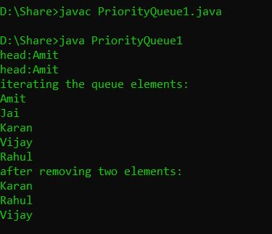**Output Screenshot**